Assume all particles behave as the d₅₀ size in the flotation feed i.e. 65 µm.

Assume particle size for maximum flotation rate is 30 µm = d_{pm} .

Assume largest floatble particle = 500 µm

Eqn 9.128 gives

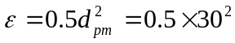

Eqn 9.126

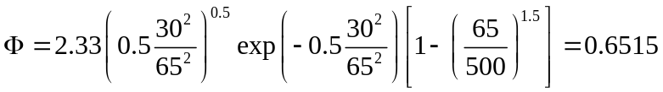

Assume bubble residence time = 1.5 s
Assume aeration rate = 1ft³/min per ft³ of cell volume. This is the old Denver standard for flotation cells.
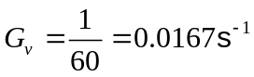
Assume bubble size = 1 mm

Eqn 9.34

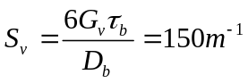

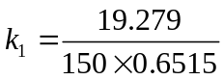 m/s
etc

